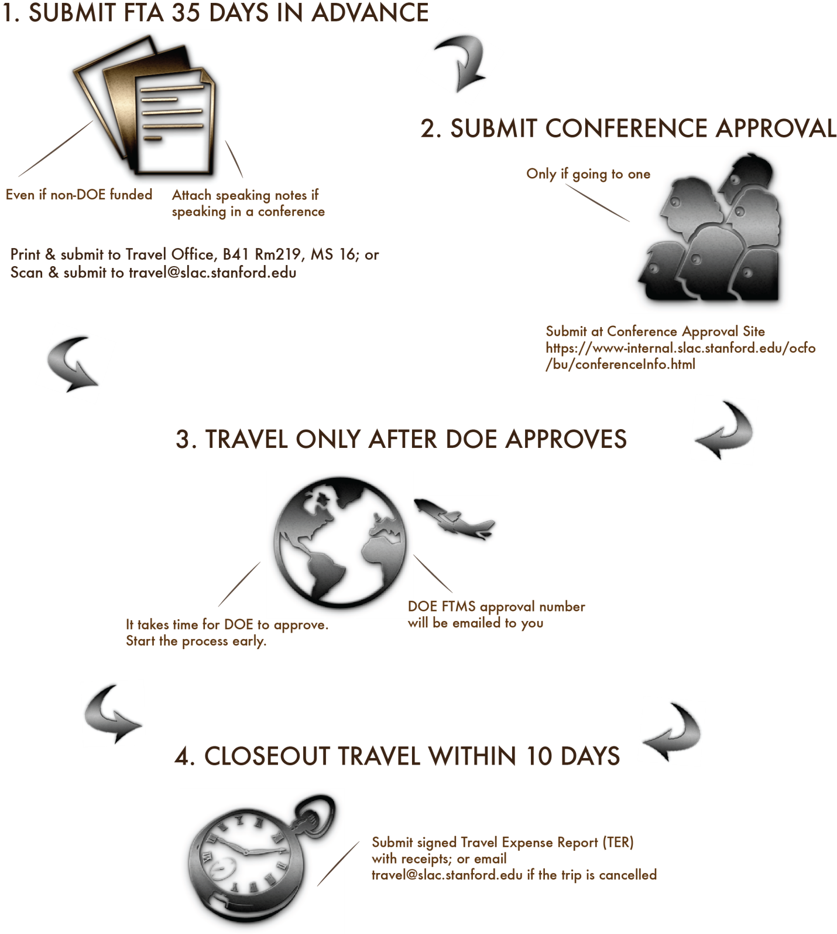

This form is used to collect data necessary to support the DOE Foreign Travel Management System (FTMS). Items marked with * must be completed.

Travel Office Use Only
FTMS# | Ecc# | SAFE Required? | Travel Dates:
Presentation Notes/Abstract/Agenda Foreign Funded Airfare Comparison Personal Travel
Notes:

Section I. – Traveler Information (To be completed by traveler)
1. *Last Name  Uemura | *First Name  Sho |  |  | *Middle Name or NMN
ONLY fill items 2-14 if this is your first SLAC foreign travel or if any data needs updating in FTMS
2. *Last 4 Digits of SSN (if available) : 6118
3. *Passport Number  463741361 | 4. *Passport Country  United States |  |  | 5.*Expiration Date (mm/dd/yyyy)  12/21/2019
6. *Gender  Male Female |  | 7. Permanent Resident Green Card Holder?  Yes No
8. *Birth Place Country  United States |  | 9. *Citizenship  United States
10. Employment Address: SLAC or
*Street Address
*City *State *Zip
11. Contact Information

*Work Phone:
Work Fax:
Home Phone:
International Cell Phone:
Domestic Cell Phone:
*E-mail Address:
12. Travel Administrator’s Email Address (to get copied on trip approvals):

13. *Position/Title
14. *Indicate whether you have held a DOE security clearance
Yes No If yes, indicate the highest level received

Section II - General Trip Information
Use additional general trip information pages as required and include all funding types estimated for this trip request.

15. *Place of Departure (City, State, Country) | 16. *Departure Date: Click here to enter a date.
15. *Place of Departure (City, State, Country) | 17. *Return Date: Click here to enter a date.

18. *Estimated travel costs by funding type
Primary  Sponsor | Funding Type | Charge Number |  | Estimated Airfare | Estimated Other
Yes
Yes
Yes
19. Type of Travel: |  |  | 20. If not coach, give justification for premium travel:
21. Names and Organizations of other personnel accompanying the traveler as a team

22. *Benefit to Government (include benefit to present position and the department)

23. Comments:

24. *Has the traveler contacted his/her Medical Support Staff to ensure awareness of safety & health issues of the country(ies) to be visited? Yes No
25. Will the traveler be taking DOE or laboratory owned equipment on this travel? Yes No

Section III – Trip Itinerary
Account for the entire timeframe between departure and return by completing a separate itinerary for each city/country to be visited (for the exception of personal leave).

26a. *Is this part of the trip associated with a conference? Yes No Unknown
If yes, submit conference attendance form(s) 90 days before start date and complete item 26b
26b. Complete this section if attending a conference (if presenting, please include draft of notes and agendas)
Conference Name:
Conference Start Date: Click here to enter a date. Conference End Date: Click here to enter a date.
URL:
27. *Destination City, Country: |  |  | 28. *Start Date: Click here to enter a date.
 |  |  | 29. *End Date: Click here to enter a date.
30. *Select One or More Primary Purpose(s)  Professional conference or workshop  Seminar/Symposium  Working group or colloquia (scientific meeting)  Site Visit  Research & Development activities under an informal, lab-to-lab, or government agreement |  |  | Meeting(s) on scientific, technical, project or programmatic matters  Procurement-related matters  Official Stop Over  Permanent Change of Station  Other(s):
Personal Leave Start Date Click here to enter a date. End Date: Location:
31. *Justify Trip Purpose (i.e. Topics to be discussed, formal presentation or paper)
The Heavy Photon Search (HPS) conference will meet at Orsay on July 1-3, 2015 to review the 2015 Engineering Run of the HPS experiment in JLab. Report on the run conditions as well as conditions of all the HPS subsystems will be included. Preparations for data analysis and opportunities for future runs will also be discussed.

The meeting will include a special workshop, "New Frontiers in Dark Matter and Dark Force Experiments" on Thursday, July 2nd. The workshop will include overview talks on the status of the heavy photon hypothesis, discussion of recent astrophysical and cosmological data pertaining to heavy photons, and descriptions of proposed new experiments.

I will make a presentation; working title is "Vertexing performance of HPS"

This part of the trip involves:  *32. Lab-to-Lab agreement? Yes No  *33. University-to-Lab agreement? Yes No  *34. International agreement? Yes No  If yes, enter agreement:  *35. Will classified information be discussed? Yes No  *36. Is the traveler planning on interacting with anyone  from a DOE-designated sensitive country? Yes No  *37. Does this Itinerary involve Training? Yes No  *38. Will any part of the trip discuss sensitive subjects?  Yes No |  |  |  |  | *39. Will any part of the trip discuss sensitive subjects as defined by DOE’s Sensitive Subject List? Yes No  *40. Will any part of the trip involve information that is subject to US Export Control restriction? Yes No  *41. Meeting with senior government official(s)? (for non-DOE employees) Yes No  i. Please provide official’s name, position, and contact information. Describe meeting goals:  *42. Embassy assistance will be required? Yes No  If yes, please describe.
43. Contacts
*Host Name | *Host Phone | *Affiliated Institution |  |  |  | *Facility to be visited | *Date Visited
*Hotel/Lodging Name  Hotel d'Orsay |  |  |  | *Hotel/Lodging Phone  01 64 86 17 47
44. Emergency next-of-kin Contact (*for travel to Germany & Switzerland)
Name: Telephone Number:
Click for additional Section III

Late Foreign Travel Approval Waiver (if submitting less than 35 days)
*Please explain why this is submitted after the deadline:

Reviews and Approvals
I. *Traveler
Name (Type or Printed):
Title:
Organization:
Signature ____________________________________ Date ______________________
Comments:
II. *Supervisor Approval
Name (Type or Printed):
Title:
Organization:
Signature ____________________________________ Date ______________________
Comments:
III. *Business Manager/Planner (per AID Matrix) Approval
Name (Type or Printed):
Title:
Organization:
Signature ____________________________________ Date ______________________
Comments:
IV. Optional Approval for Directorate Use Only
Name (Type or Printed):
Title:
Organization:
Signature ____________________________________ Date ______________________
Comments:

