S3P Top-Level Commands

- ModelInfo
- FiniteElement
- FrequencyScan
- Port
- Loading
- LinearSolver
- PostProcess

Note: Refer to acdtool command syntax for postprocessing capabilities.

Back to Index

ModelInfo
ModelInfo :
{
File: ./recWG-load1.ncdf

BoundaryCondition : {
Magnetic: 1
Exterior: 6
Waveguide: 7
}

SurfaceMaterial : {
ReferenceNumber: 6
Sigma: 5.8e7
}

Material : {
Attribute: 1
Epsilon: 1.0
Mu: 1.0
}

Material : {
Attribute: 2
Epsilon: 10.0
Mu: 1.0
EpsilonImag: -1.52
}

Material : {
Attribute: 2
PML: {
Type: Face
BoundaryID: 6
Thickness: 0.02
Start: -0.01143 -0.00508 0.08
End: 0.01143 0.00508 0.10
Direction: 0. 0. +1.
Reflection Coefficient: 1.e-5
Polynomial Order: 2
Maximum Sigma: 2.e0 2.e0 2.e0
}
}

Material : {
Attribute: 2
PML: {
Type: Face
BoundaryID: 6
Thickness: 0.004
SubType: Sphere
Radius: 0.05
Direction: 0. 0. +1.
Reflection Coefficient: 1.e-5
Polynomial Order: 2
}
}

SurfaceMaterial: {
ReferenceNumber: 3
Sigma: 5.8e7
Frequency: 5e9
Coating: {
Type: ThinLossyDielectric
Epsilon: 56
Sigma: 12
Thickness:1.e-3
} // For surface impedance boundary with thin lossy dielectric on conductor
}

}

ModelInfo specifies the model used for s3p simulation.
File: The name of the mesh file in netcdf format. It can be located in a directory specified by the path. If the path is not specified, the default is the directory where the job is submitted.
BoundaryCondition specifies the boundary conditions on all the surfaces of the mesh. Every single surface of the mesh has a reference number which is set in Cubit and each reference number is associated with a boundary condition. The types of boundary condition used in s3p are
- Electric: The tangential component of the electric field is zero. It can be used to define a symmetry plane in the model.
- Magnetic: The tangential component of the magnetic field is zero. It can be used to define a symmetry plane in the model.
- Exterior: The tangential component of the electric field is zero. Computationally it is equivalent to Electric boundary condition, but used normally for perfectly conducting cavity surface. For normal conducting surface, it can be used for calculating power loss on the surface using perturbation theory.
- Impedance: The electric and magnetic fields are related by the conductivity of the boundary surface for imperfect conductor; useful for self-consistent field calculation for finite loss of a conductor when the skin depth is small compared with the finite element sizes in the mesh. The conductivity is specified in SurfaceMaterial. The conductivity is assumed to be constant, specified at a certain frequency.
The surface impedance boundary condition can also be used to model thin lossy dielectric layer deposited on a conductor surface. One needs to specify the dielectric properties and thickness of the dielectric material.
- Absorbing: Absorbing boundary condition (ABC) allows electromagnetic waves propagating at the speed of light to pass through the boundary without reflection. It is used for coaxial waveguides.
- Waveguide: Waveguide boundary condition to account for the dispersive propagation of electromagnetic wave in waveguides.

Material specifies the material properties of a region in the model. If not specified, the region is set to vacuum. Every region of the mesh has a reference block number which is set in Cubit.
- Attribute: The region/volume ID
- Epsilon: Relative permittivity of the region
- Mu: Relative permeability of the region
- EpsilonImag: Imaginary part of the relative permittivity of the region associated with material loss. The default is zero.
- MuImag: Imaginary part of the relative permeability of the region associated with material loss. The default is zero.
- PML: Container to specify perfectly matched layer (see setup below)
SurfaceMaterial specifies the external wall material properties, which are used to model the power loss on the surface.
- ReferenceNumber: The reference number of the surface set in Cubit
- Sigma: Conductivity of the surface [unit in s/m]. If not specified, the exterior wall is copper with conductivity of 5.8e7 s/m.
- Frequency: Frequency at which conductivity is specified [unit in Hz]
- Coating specifies the material properties of a thin dielectric deposited on a conductor surface.
  - Type: Type of coating layer
    - ThinLossyDielectric: Thin lossy dielectric layer
  - Epsilon: Relative permittivity of layer
  - Sigma: Conductivity of layer [unit in S/m]
  - Thickness: Thickness of layer [unit in m]

PML terminates wave propagation by absorption in artificially lossy layers.
- Free space termination set by Face, Edge and Corner layers
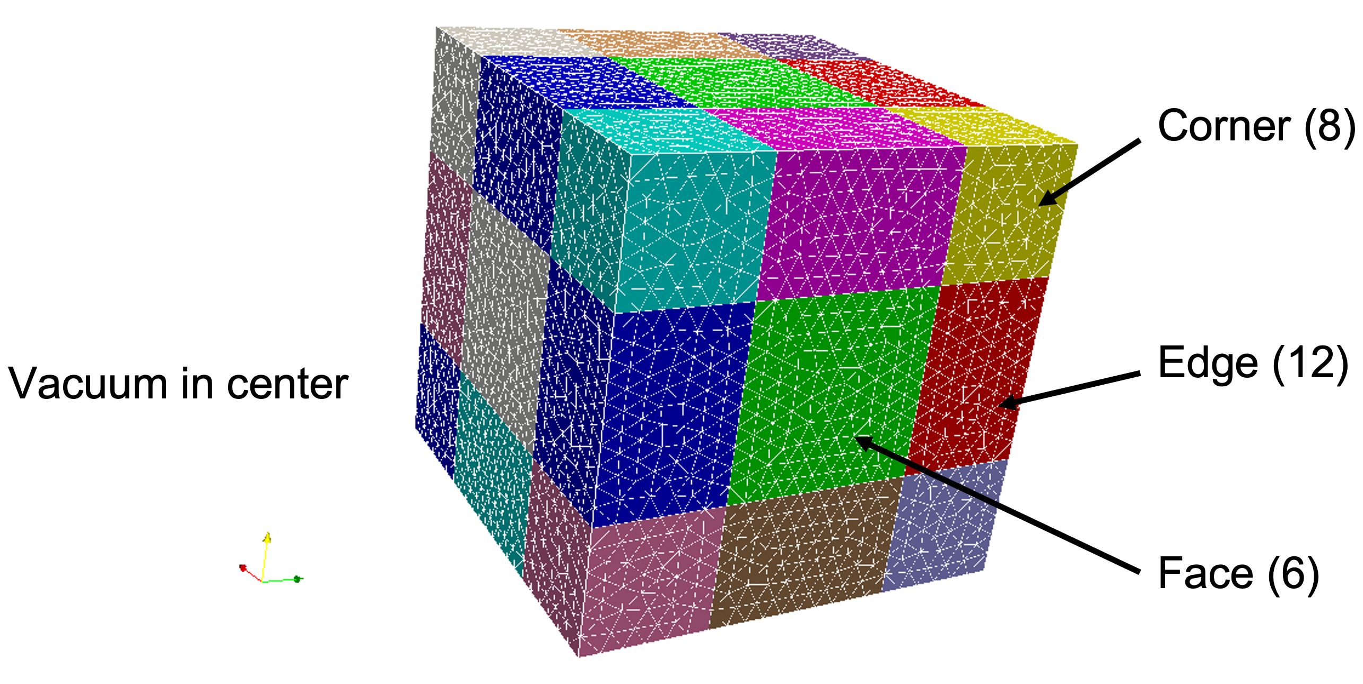
- Waveguide termination set by Face layer
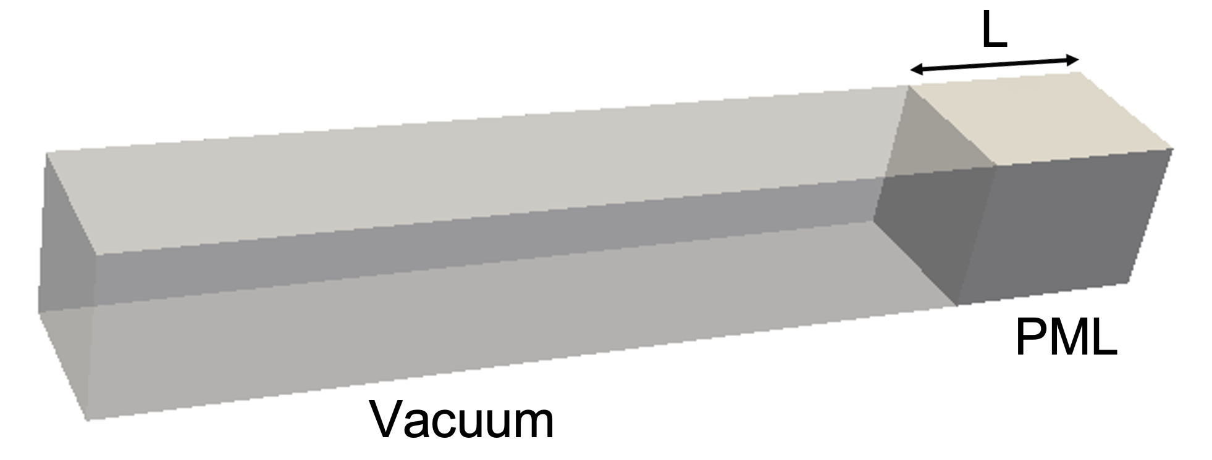
- PML parameters specified by the following model
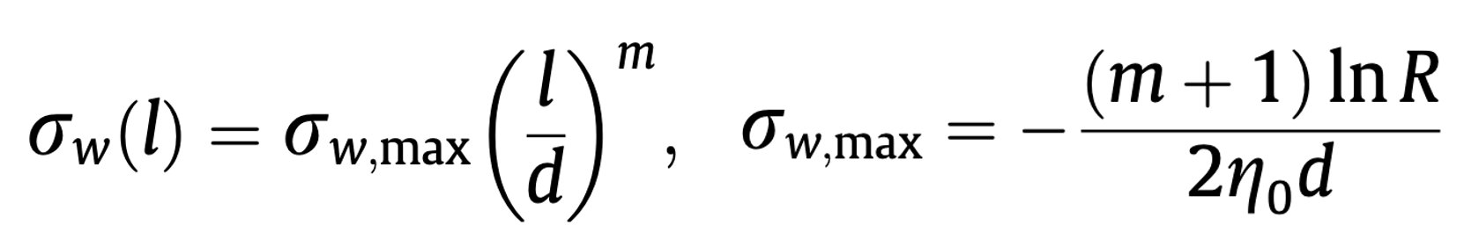
where s_{w} is the conductivity set by s_{w,max}, thickness d, order m and location in layer. R is the reflection coefficient from the PML.
PML container specifications
- Type: Type of PML layer
  - Face: 6 orientations specified by Direction
  - Edge: 12 orientations specified by Direction
  - Corner: 8 orientations specified by Direction
- Start: x, y, z
Lower bound coordinates (x, y, z) of layer’s bounding box [units in m]
- End: x, y, z
Upper bound coordinates (x, y, z) of layer’s bounding box [units in m]
- Direction: ix, iy, iz
Orientation of layer:
(+/- 1, 0, 0), (0, +/- 1, 0), (0, 0, +/- 1) for Face layer
(+/- 1, +/- 1, 0), (0, +/- 1, +/- 1), (+/- 1, 0, +/- 1) for Edge layer
(+/- 1, +/- 1, +/- 1) for Corner layer
- Reflection Coefficient: Reflected from PML; if specified, Maximum Sigma will be calculated.
- Maximum Sigma: Conductivity in x, y, z directions [units in S/m]

Spherical and cylindrical PML has slightly different specifications which requires the simulation model with a spherical or cylindrical layers. No bounding box and direction (Start, End and Direction) need to be specified. Additional parameters are
- BoundaryID: Reference number of PML outside surface
- Thickness: Spherical or cylindrical layer thickness [unit in m]
- SubType: Sphere for spherical PML; Cylinder for cylindrical PML; Note PML Type is Face.
- Radius: Radius of spherical or cylindrical PML [unit in m]

Back to Index

Back to Index

FiniteElement
FiniteElement:
{
Order: 2
CurvedSurfaces: on
}

FiniteElement specifies parameters for the finite element method.
- Order: The order of the finite elements used in the simulation. Order 1-6 have been implemented. The higher the order is, the more accurate the calculation is and the more computational resources are for a fixed mesh. For most applications, using 2nd order is good enough to obtain the solution accuracy.
- Curved Surfaces: on or off
on: The surfaces of the finite elements on the model surface are represented by curved surfaces to better approximate the geometry. If no specified, curved surfaces are used.
off: The surfaces of the finite elements on the model surface are represented by flat surfaces.

Back to Index
FrequencyScan

FrequencyScan:
{
Start: 9.424e+9
End: 14.424e+9
Interval: 0.2e+9
}

FrequencyScan specifies the frequency range for S-parameter calculation.
- Start: Start frequency [unit in Hz]
- End: End frequency [unit in Hz]
- Interval: Frequency sweep interval [unit in Hz]

If the “Interval” is larger than the difference of “End” and “Start”, the S parameter will be calculated for the “Start” frequency only.

Back to Index

Port
Port :
{
ReferenceNumber : 7
NumberOfModes : 2
}

Port specifies the number of waveguide modes loaded on an open port. If not specified, only the lowest waveguide mode on the open port will be loaded.
- ReferenceNumber: The number should match the waveguide boundary ID.
- NumberOfModes: The number of modes loaded on the port

Back to Index
Loading
Loading:
{
Type: DipoleLoading
Coordinate: 0., 2., 0.
Direction: 0.0, 1.0, 0.0
Tolerance: 0.001
Power: 1.
Frequency: 30.e3
}

Loading specifies the information for dipole excitation in s3p. The type of loading is specified by the following.
Type: Loading type
- DipoleLoading: Excitation of an electric dipole at a point in the computational volume

(1) For DipoleLoading, specify the following parameters.

Coordinate: x, y, z
The location of the dipole at the coordinates (x, y, z) [units in m].

Direction: x, y, z
The direction of the dipole.

Tolerance: Set the tolerance that the dipole Direction aligns with the edge of the element closest to the dipole Coordinate.

Power: Electric dipole moment [unit in A-m].

Frequency: Excitation frequency [unit in Hz].

Back to Index

LinearSolver
LinearSolver: {
Solver: GMRES
Preconditioner: MP
MaxIterations: 5000
Tolerance: 1e-10
PrintFrequency: 50
QuietMode: 0
}

LinearSolver specifies linear solver when the default direct Solver: MUMPS is not used. Multilevel hierarchical preconditioner MP works with an iterative solver to achieve solution convergence. FiniteElement Order needs to be set to 2 and GMRES is the preferred linear Solver.

- Solver: MUMPS, GMRES, CG, QMR
- Preconditioner: MP: Multilevel hierarchical preconditioner; MUMPS is first to find the solution using 1st order finite element to build the preconditioner, which is then used for the iterative solver using 2nd order finite element.
- MaxIterations: Maximum number of iterations
- Tolerance: Number for convergence (default is 1e-10)
- PrintFrequency: Interval between printing out iteration status
- QuiteMode: 0 or 1
0: Print
1: Do not print

Linear solvers from PETSc can also be used.
Real case (lossless):
LinearSolver: {
Solver: PETSc
Preconditioner: MP
SubCommSize: 8
Tolerance: 1e-10
MaxIterations: 8000
PETScOption: {
Runtime: -ksp_type cg -log_view -options_left -ksp_converged_reason
}
}

Complex case (lossy materials):
LinearSolver: {
Solver: PETSc
Preconditioner: MP
SubCommSize: 8
Tolerance: 1e-10
MaxIterations: 8000
PETScOption: {
Runtime: -ksp_type gmres -log_view -options_left -ksp_converged_reason
}
}
Using PETSc built-in preconditioners (without MP):
LinearSolver: {
Solver: PETSc
Tolerance: 1e-10
MaxIterations: 8000
PETScOption: {
Runtime: -ksp_type cg -pc_type jacobi -log_view -options_left -ksp_converged_reason
}
}

Parameters:
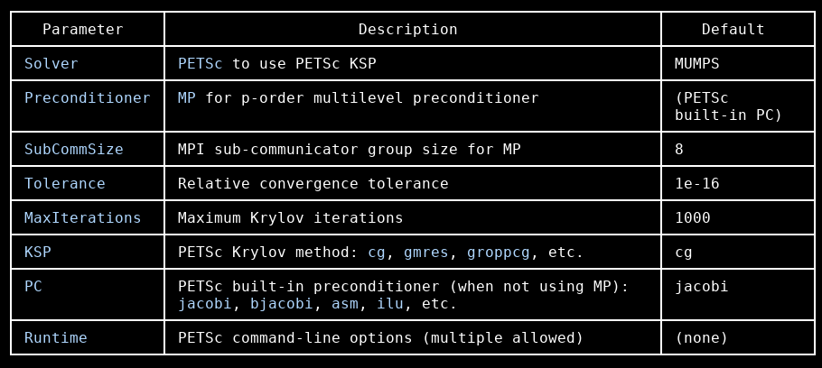

Notes:
- Use KSP: cg only for real symmetric/Hermitian systems
- Use KSP: gmres for complex (lossy) systems — CG will diverge
- Complex case requires binaries from bin-petsc-complex
- Multiple Runtime entries are supported for multiple PETSc options
See https://petsc.org/release/manual/ for details.

Back to Index

Postprocess
PostProcess :
{
Toggle: on
PortNumber: 7
ModeFile: rec
WriteLoss: on
}

Postprocess specifies postprocessing options.

- Toggle: on or off
on: Mode files named *.mod will be created for the port for visualization and analysis. This is the default option.
off: No mode files named *.mod will be created for the port.
- PortNumber: The reference number of the port
- ModeFile: the prefix of the mode files. The default is “s3p”.
- WriteLoss: on or off
on: Mode files named *.loss will be created for power density distribution.
off: No mode files named *.loss will be created for power density distribution [default].

Back to Index

